Project Idea: Implementation of market neutral income option strategy: Iron Condor

· The income in ***Income option strategy*** comes from ***Positive Theta***

o ***Sell near the money options and buy options that are further out of the money***

o ***Sell short term options and buy longer term options***

o ***For every options sold, buy an option of the same type (call or put) to limit risk and reduce required capital***

· Option income strategy to be employed using options that are chronically overvalued… implies implied volatility ***(annualized standard deviation , level of volatility that is implied by price of the option)*** is consistently higher than statistical volatility ***(annualized standard deviation of percentage price changes of the underlying security)***

· ***Market neutral strategy***

o Positive Delta represents a bullish position that benefits from an increase in the price of underlying

o Negative Delta represents a bullish position that benefits from an decrease in the price of underlying

o Delta of zero or near zero represents a neutral position that benefits from no or slight movement in the price of underlying

· Iron Condor Strategy:

o It requires 4 separate option positions (or leg).

§ 2 long (Buy) and 2 short (Sell)

o The short strikes positioned a significant distance above and below of current price of the underlying security

o The long strikes will be located slightly beyond the short strikes. This limits

§ the potential losses

§ capital requirement to implement strategy

o We can construct condor with all calls, all puts or with a combination of calls and put options.

§ If we use all calls or all puts to create condor, we would be required to buy and sell options deep in the money (ITM). ITM options are typically illiquid and trade infrequently and therefore it has higher transaction costs

§ Minimizing transaction costs is essential to the success of the condor strategy

§ So we opts for

· selling an OTM call credit spread (means selling a OTM call option and buying another call option further OTM; and

· selling an OTM put credit spread (means selling a OTM put option and buying another put option further OTM.

§ Call and put spreads both generates credits and hence call credit spread

§ OTM/ATM put/call options are frequently used by hedgers to hedge long and short positions and hence more liquidity

o How do we create a Delta neutral iron condor -to minimize the market risk at inception :

§ ‘***Delta*** of short call should be approximately equal to ***Delta*** of short put

§ ‘***Delta*** of long call should be approximately equal to ***Delta*** of long put

o Condor -entry technique :

§ Identify the trade required to implement the Delta neutral iron condor strategy

§ We should enter into iron condor with one single limit order on the 4-leg spread

o Underlying

§ Indexes is more liquid and price effective than related ETF’s

§ While selling options, we would prefer that the theoretical probabilities of touching the short strike price is greater than the realized probability of touching the short strike

§ OTM short call probability advantage is consistently positive over 0.75 SD for holding periods upto 60 days.

§ Equity options with lower strike prices have higher IV

· **Greeks**

o ***Theta*** represents source of income or return

o Following other Greeks represent a source of risk

o Delta

o Gamma

o Vega

o Rho

o Our endeavor is to increase the theta and minimize other Greeks

· Risk Return Ratios:

o DTRRR (Delta Theta Risk Return Ratios): need following to estimate DTRRR

§ No of calendar days in holding period

§ Theta

§ Underlying Price

§ Annualized Implied Volatility

§ Delta

§ Gamma

o VTRRR (Vega Theta Risk Return Ratios): need following to estimate VTRRR

§ No of calendar days in holding period

§ Theta

§ Annualized Implied Volatility – To calculate DVIV

§ Vega

o RTRRR (Rho Theta Risk Return Ratios): Insignificant effect, so ignoring for our project

Web Link: <https://www.investopedia.com/terms/i/ironcondor.asp>

**Criteria 1 : Delta neutral Strategy**

**Delta of Strategy =** Delta (Short Call) + Delta (Short Put) + Delta (Long Call) + Delta (Long Put)

Delta of Strategy should be 0 or near zero at time of trade entry.

**Criteria 2: Our minimizing function ( DTRRR + VTRRR) to be run through all the option sets to pick the lowest**

**DTRRR**

HPD = Number of Calendar Days in Holding Period

Theta Effect (TE) = Theta * HPD

IV = Annualized Implied Volatility

P = Underlying Price

EPC = Expected Price Change

EPC = P * (Exp(IV*((HPD/365)^0.5))-1)

Delta Effect (DE) = -ABS(Delta)* EPC

Gamma Effect (GE) = Gamma * (EPC^2)/2

DTRRR = (DE+GE)/TE

**VTRRR**

HPD = Number of Calendar Days in Holding Period

Theta Effect (TE) = Theta * HPD

IV = Annualized Implied Volatility

DVIV = Daily Volatility of IV

Calculation step of DVIV =

1. Calculate the daily changes in price of Underlying P =🔺P = todays price - yesterday’s price =Pn - P(n-1)
2. Square the daily changes in the price as per step 1
3. Calculate 5 days average of of the squared daily changes in Price as per step 2 for 5 trailing days = S
4. Calculate the square root of average,S as per step 3 = DVIV

ECIV, Expected change in Implied volatility over the Holding Period = DVIV * ((HPD)* 5/7))^0.5)

Vega Effect,VE = -ABS(Vega) * ECIV

VTRRR = (VE)/TE

**Criteria 3: To pick the index/ stock as underlying**

**Statistical Volatility < Implied Volatility over the holding period of Iron Condor (To be developed)**

**Implied Volatility :** It represents the expected level of volatility (price dispersion)that is priced into specific options. It is level of volatility that is implied by the price of the option

<https://www.investopedia.com/ask/answers/032515/what-options-implied-volatility-and-how-it-calculated.asp>

* Implied volatility is one of several components of the Black-Scholes formula, a mathematical model that estimates the pricing variation over time of financial instruments, such as options contracts.
* The five other inputs of the Black-Scholes model are the market price of the option, the underlying stock price, the strike price, the time to expiration, and the risk-free interest rate.
* The iterative search is one method using the Black-Scholes formula to calculate implied volatility.
* A trader can compare historical volatility with implied volatility to potentially determine if there is an underlying event that might impact a stock’s price.

**Adjustment/liquidation**

**Criteria 4 : Theta should always be positive at entry;** in case during life of Iron condor theta becomes negative, trade should be adjusted /liquidated.

Criteria 5 : Expiration Break Even Rule: We can find out the break even points on both side of Underlying price where **(To be developed -not required for trade entry strategy)**

**Criteria 5**

**Q)** What is the probability advantage of selling OTM equity index options as a function of a) the length of the holding period and b) the degree each option is out of the money

* Calculate realized probability of the price of underlying security touching the strike price of the OTM option sold any time during the holding period.
* Compare the realized touch probabilities to the theoretical probabilities of touching the short strike to determine the historical probability advantage or disadvantage. (may be using 5000-path Monte Carlo simulation from an arbitrage-free binomial lattice

**Pseudo-Code (for discussion and improvement)**

**1. Create 3 new data frame with following criteria:**

**a. ‘inTheMoney’ = False & ‘daysToExpiration’ between 15 & 30. (=df1)**

**b. ‘inTheMoney’ = False & ‘daysToExpiration’ between 31 & 60. (=df2)**

**c. ‘inTheMoney’ = False & ‘daysToExpiration’ between 61 & 90. (=df3)**

**2. Check for underlying price (closing Price) for last 6 days = [ p0, p1,p2,p3,p4, p5)**

**-Calculate the daily changes in price of Underlying P =🔺P = todays price - yesterday’s price =Pn - P(n-1)**

**Square the daily changes in the price as per step 1**

**Calculate 5 days average of the squared daily changes in Price as per step 2 for 5 trailing days = S**

**Calculate the square root of average, S as per step 3 = DVIV**

**3. Vt = Theoretical volatility**

**4. Ask user data, Time horizon, t = [ ‘LOW’, ‘MEDIUM’,’HIGH’]**

**5. If ‘t’ = ‘LOW’, df = df1**

**Elseif ‘t’= ‘MEDIUM’ df = df2**

**else df = df3**

**6. Add a column ‘RiskReturnRatio’ Rt in df**

**7. For index I**

**Ve = Vega**

**Th = Theta**

**De = Delta**

**Ga = Gamma**

**IV = Annualized Implied Volatility**

**HPD = Number of Calendar days in Holding Period = Maturity Date – now()**

**ECIV = DVIV * ((HPD)* 5/7))^0.5)**

**Vega Effect, VE = -ABS(Ve) * ECIV**

**Theta Effect, TE = Th * HPD**

**Expected Price Change, EPC = P * (Exp (IV*((HPD/365) ^ 0.5))-1)**

**Delta Effect (DE) = -ABS(Delta)* EPC**

**Gamma Effect (GE) = Gamma * (EPC^2)/2**

**VTRRR = (VE/TE)**

**DTRRR = (DE +GE)/TE**

**Rt = DTRRR +VTRRR**

**Add a column Risk Return Ratio**

**8. For ‘putCall’ = CALL & ` strike price in the range, (‘p0 + 0.75 * Vt’ to p0 + 1.25 *Vt),**

**Rt = Rt min & Symbol_CS = corresponding symbol. Dcs = Delta, Pcs = Strike Price**

**9. For ‘putCall’ = CALL & ` strike price in the range, (‘Pcs + 15’ to Pcs + 35),**

**Rt = Rt min & Symbol_CL= corresponding symbol. Dcl = Delta, Pcl = Strike Price**

**10. For ‘putCall’ = PUT & ` strike price < (‘p0 – (Pcs-P0)* 1.25)**

**Delta_diff = [Abs(Delta – Dcs)]**

**Check for min Delta_diff**

**Dps = corresponding Delta, Symbol_PS = corresponding symbol Pps = Strike Price**

**11. For ‘putCall’ = PUT & ` strike price < (‘Pps – (Pcl-Pcs)*1.25)**

**Delta_diff = [Abs(Delta – Dcl)]**

**Check for min Delta_diff**

**Dpl = corresponding Delta, Symbol_PL = corresponding symbol**

**12. Max Income, I = Price of CS + Price of PS – Price of CL -Price of PL**

**13. Maximum Loss, Pot_Loss = Max[( Pps- Ppl), (Pcl-Pcs)]-I**

**14. Break Even Lower be_lower= Pps- I**

**15. Break Even Upper, be_upper= Pcs + I**

**Recommendation:**

**Call Short: Symbol_CS**

**Call Long: Symbol_CL**

**Put Short: Symbol_PS**

**Put Long: Symbol_PL**

**Maximum Possible Profit = I**

**Maximum Potential Loss = Pot_Loss**

**Profitable Price Range = ( be_lower, be_upper)**

**Visualization Ideas**

Idea 1

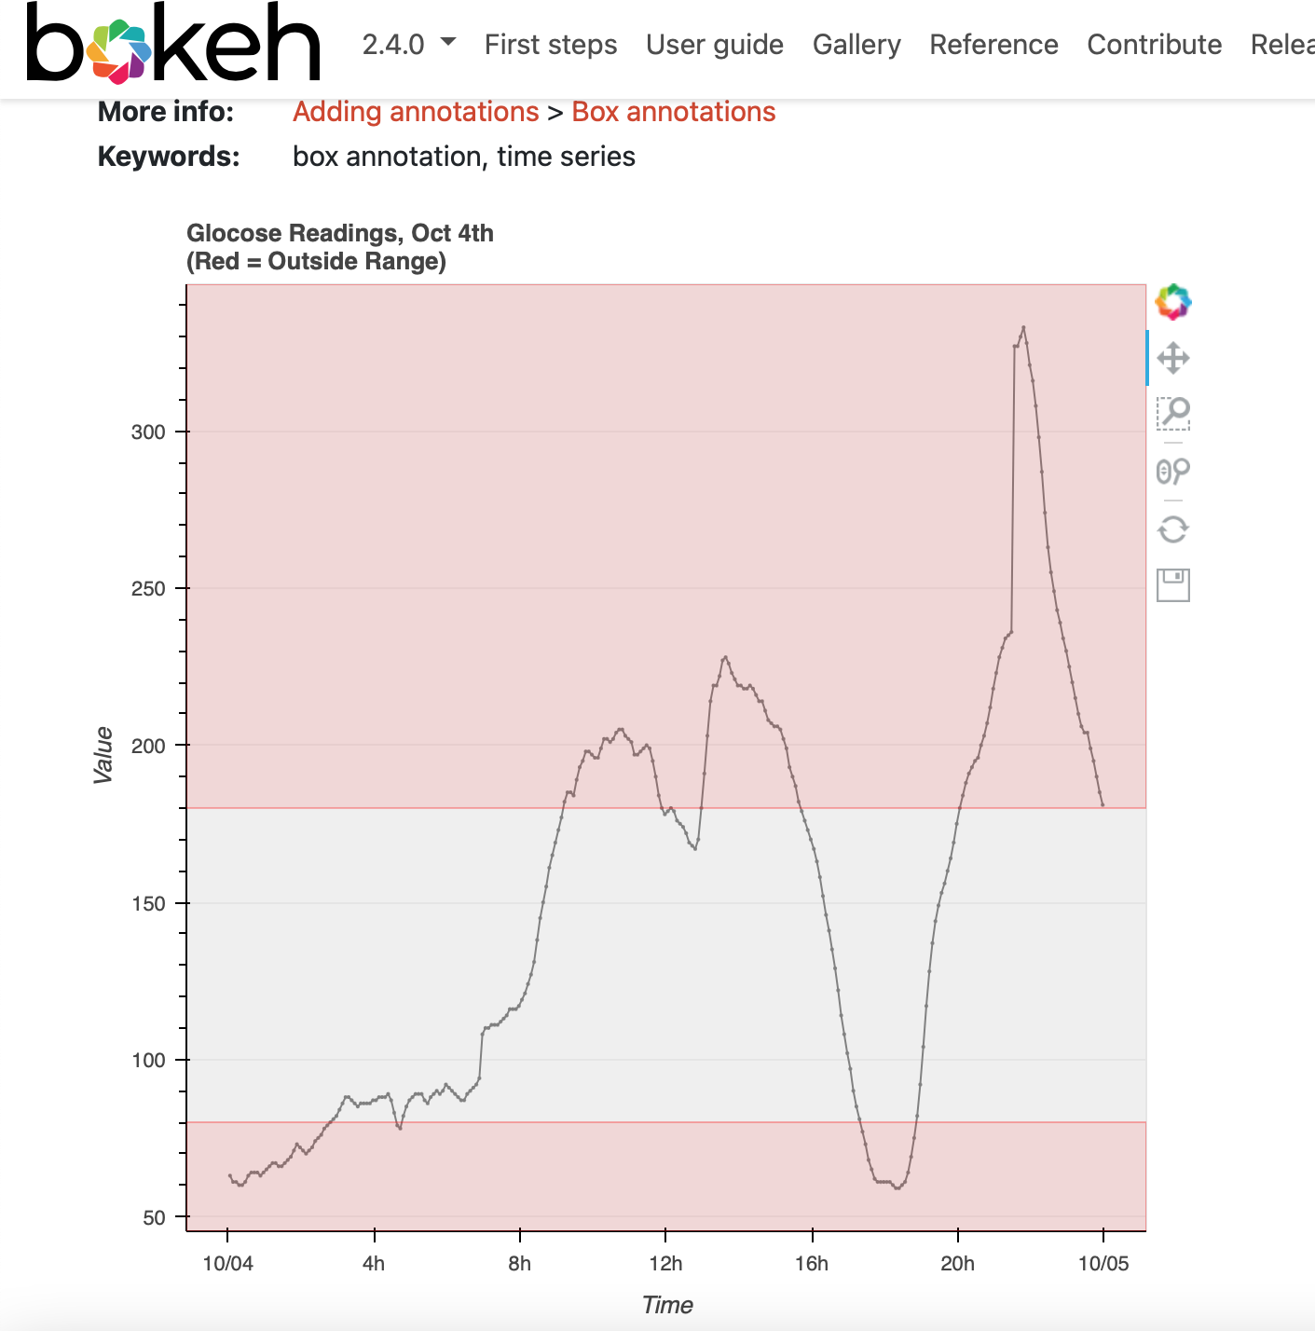

In this chart, the data can be shown with short short put or calls in the red interchangeably. The chart could be overlapped or be shown side by side with one grapp focusing on puts and the other focusing on calls.

Idea 2

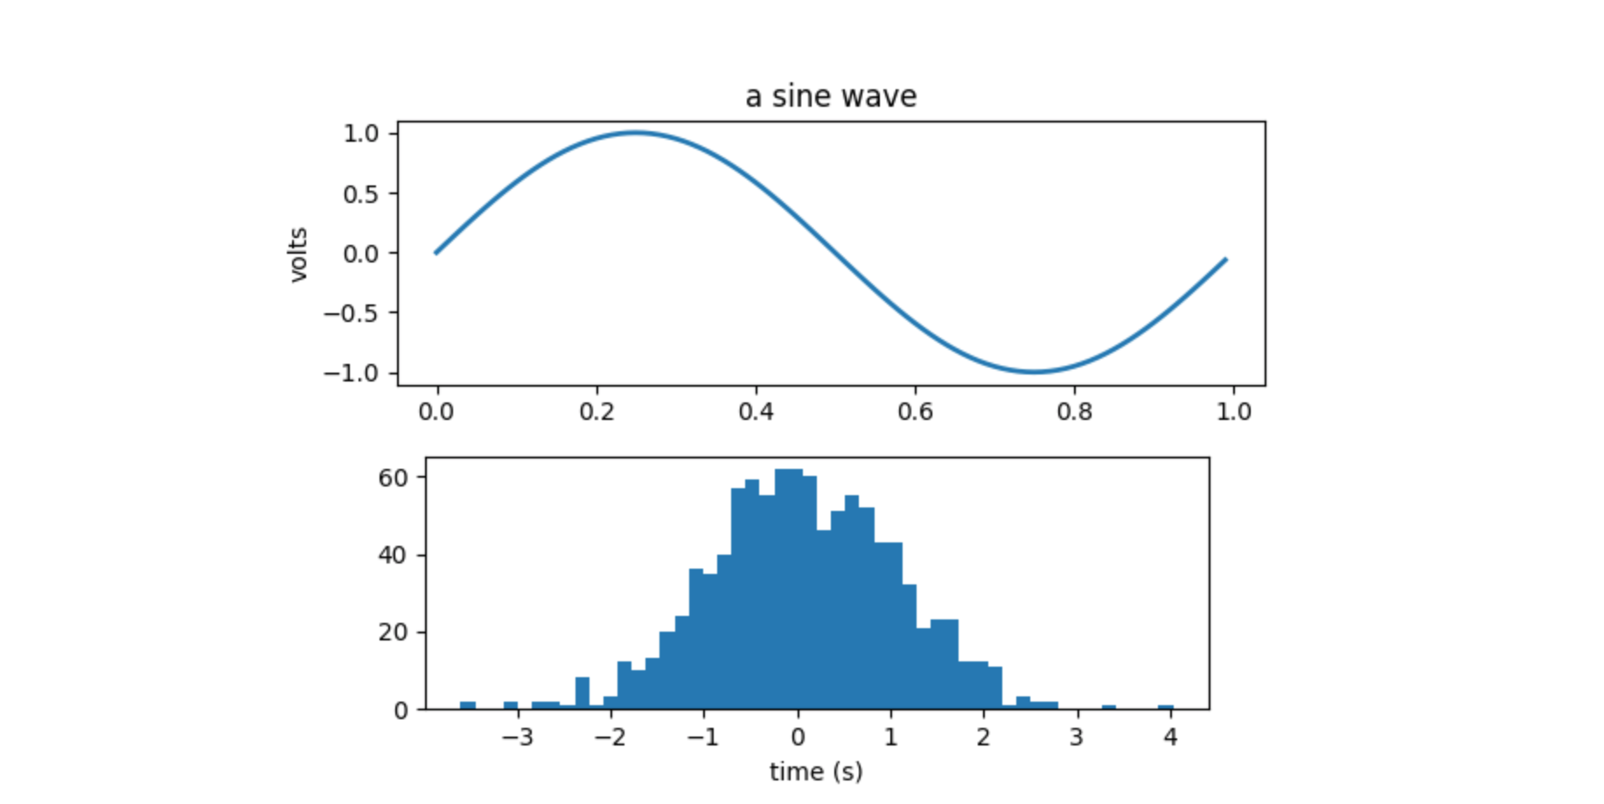

In this graph we can compare volatility and price movement simultaneously

Idea 3

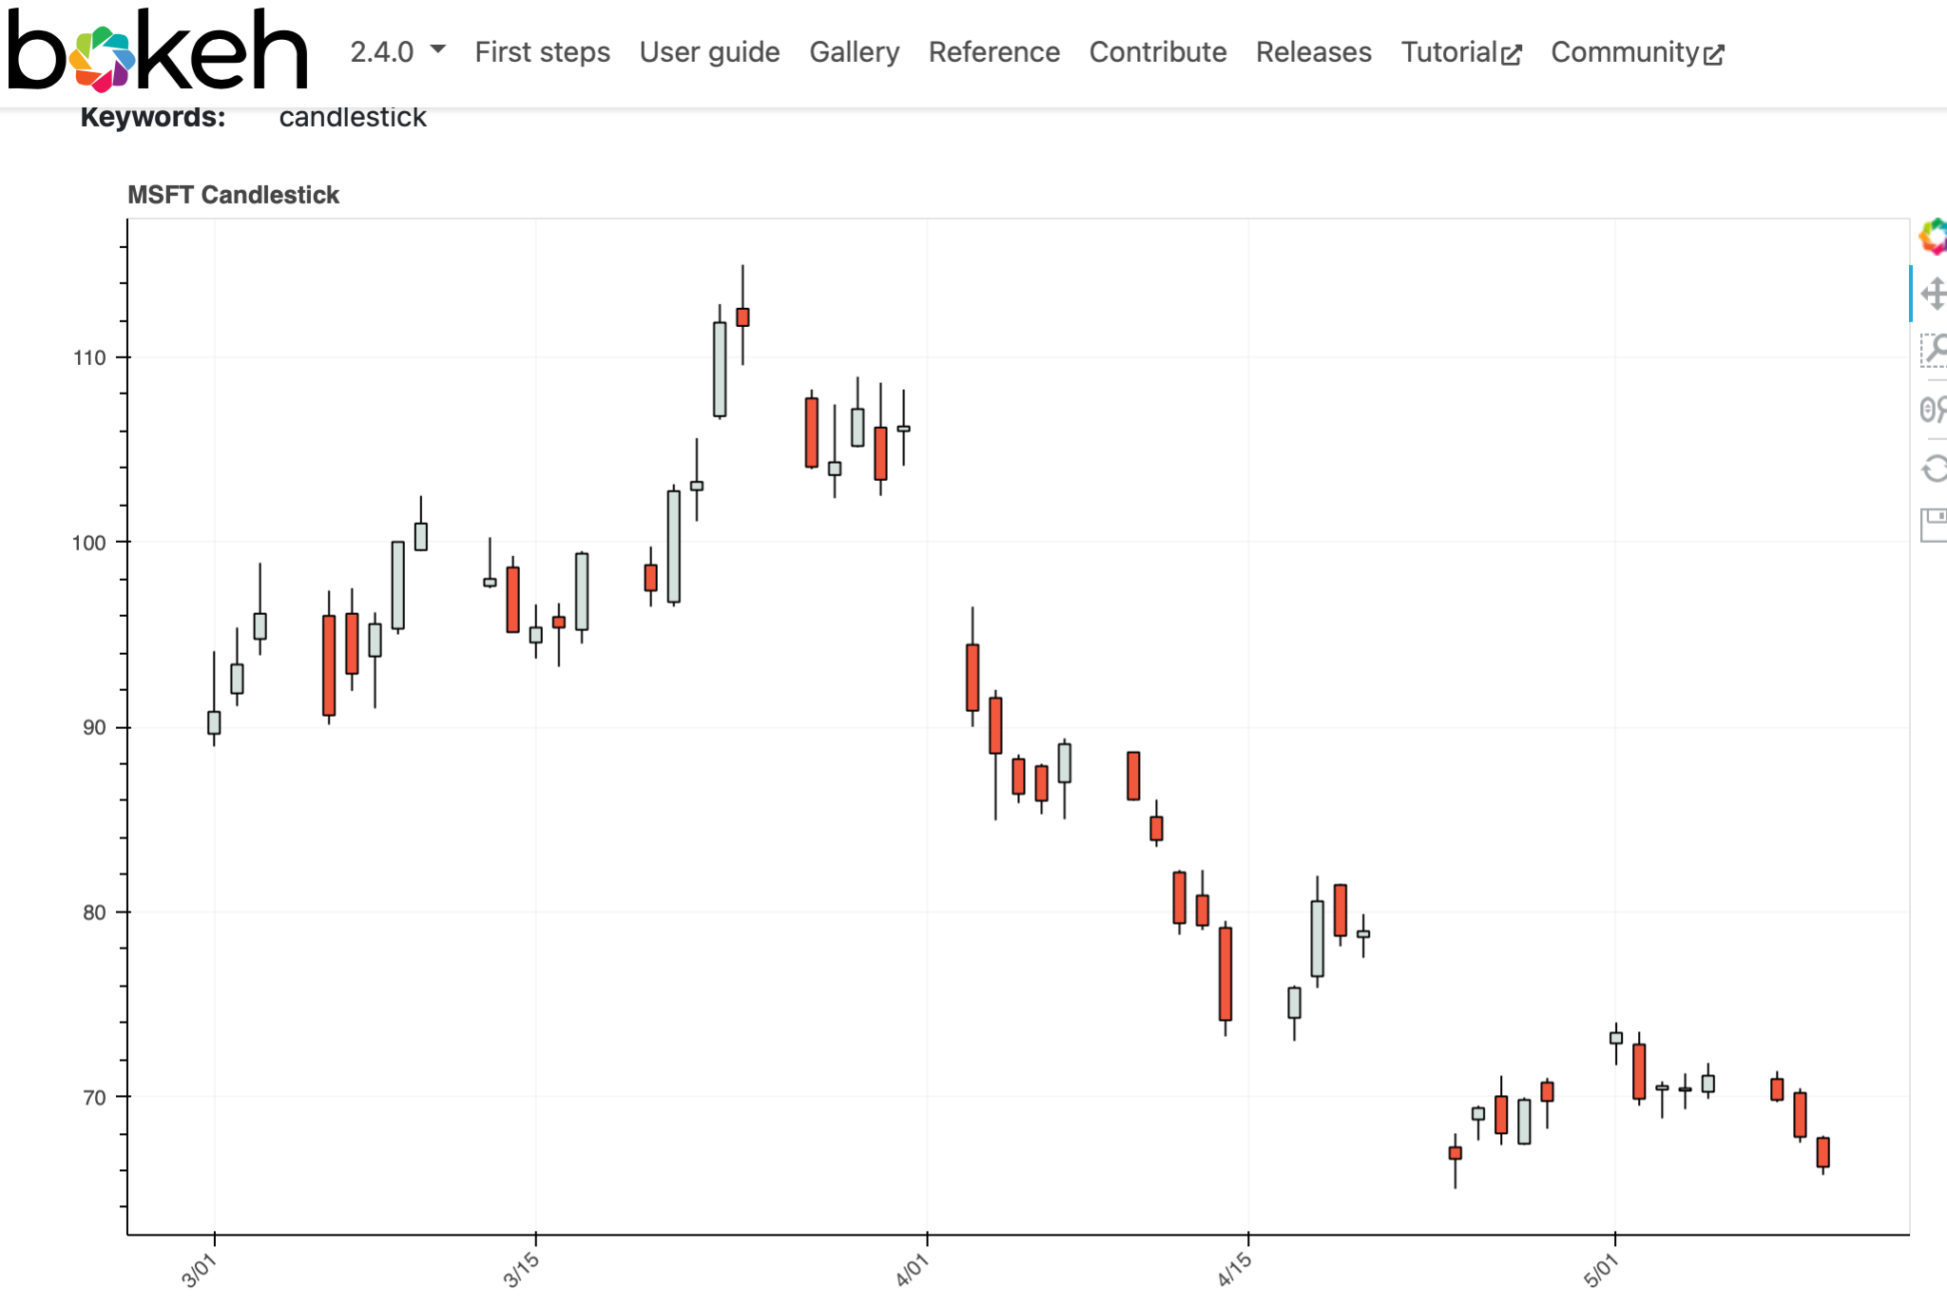

Plug in data to show a candlestick view of the stock we gathered information for. Showing data for opening and closing prices and high and low prices. This graph could be used as a lead up to compare volatility.

Idea 4

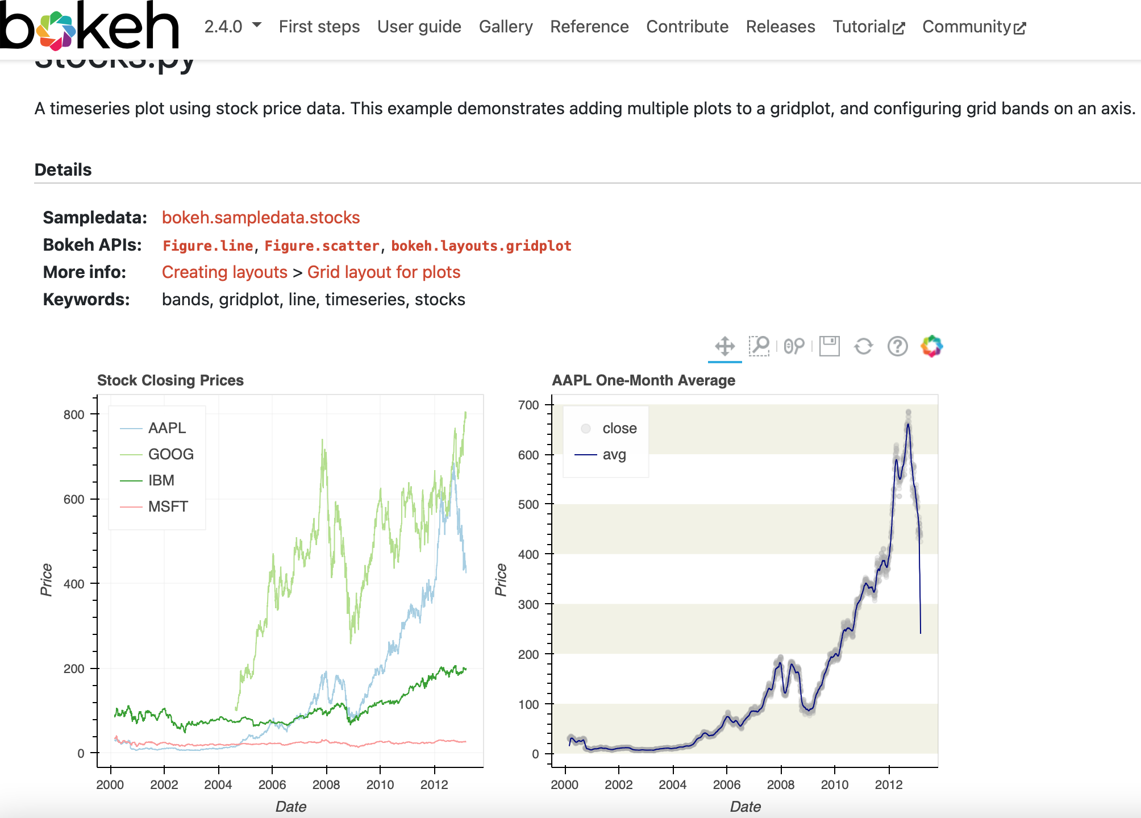

Idea 5

<https://medium.datadriveninvestor.com/visualizing-option-trading-strategies-in-python-35bfa61151d9>

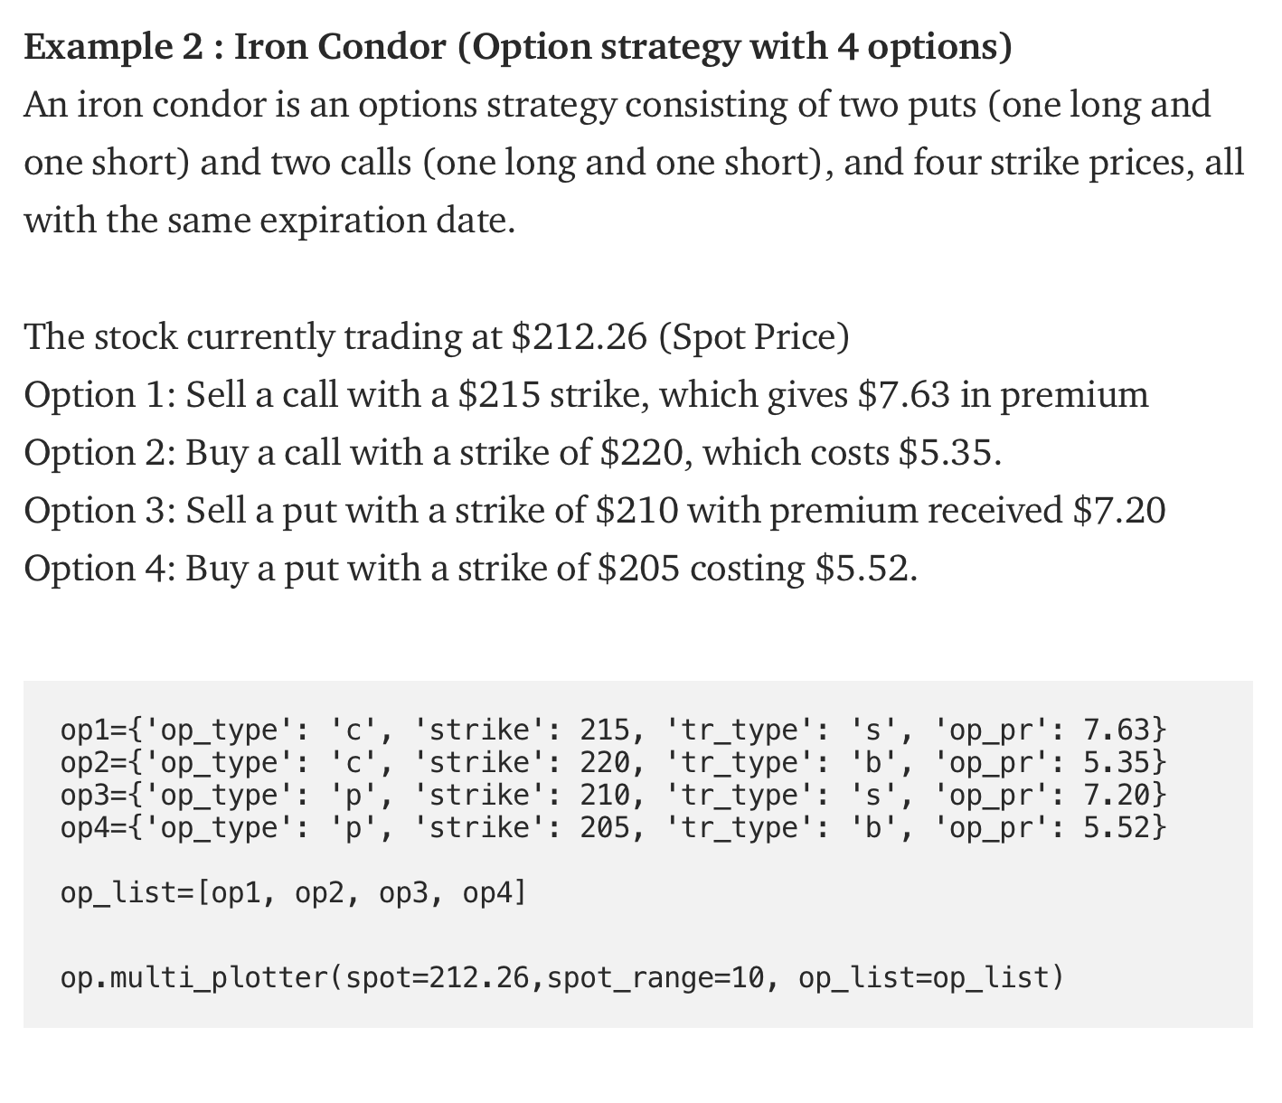

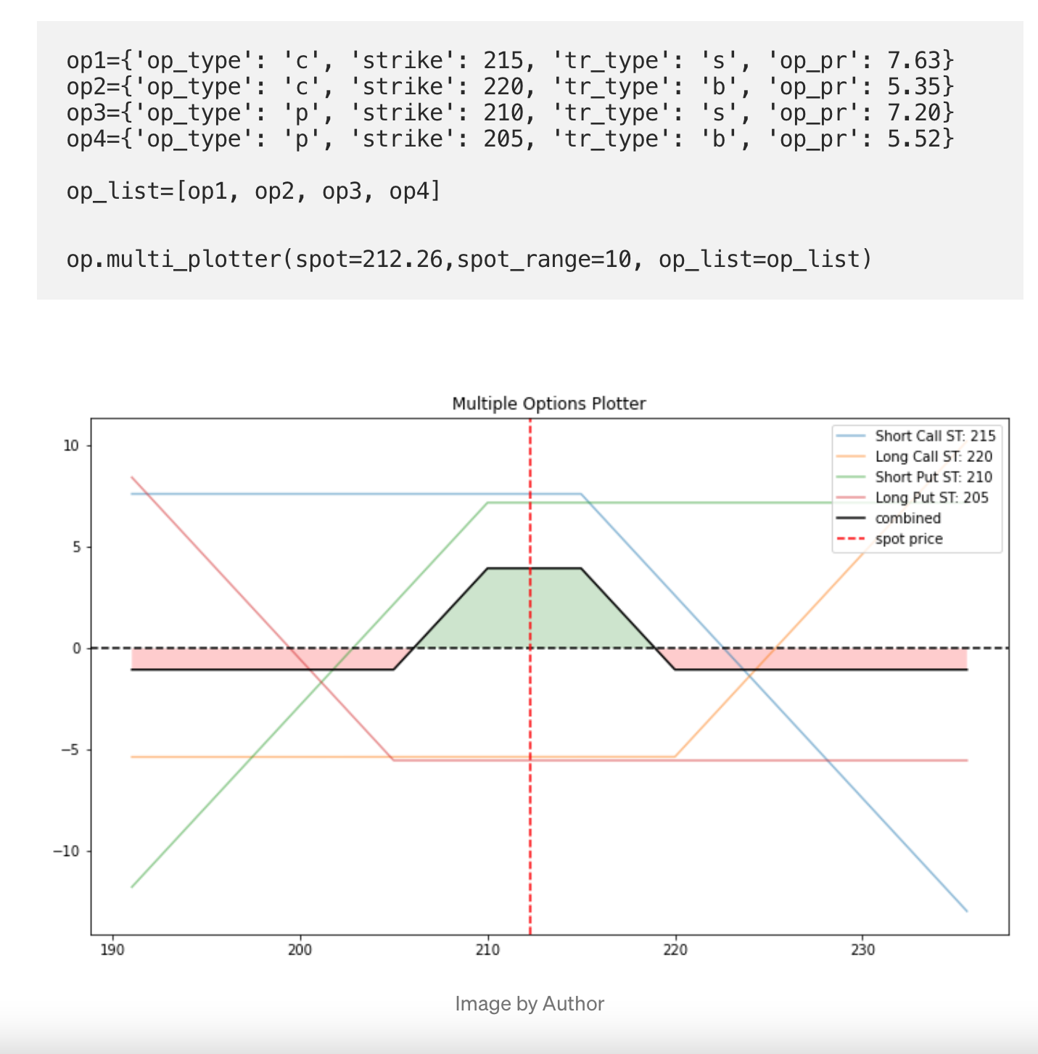

Idea 6

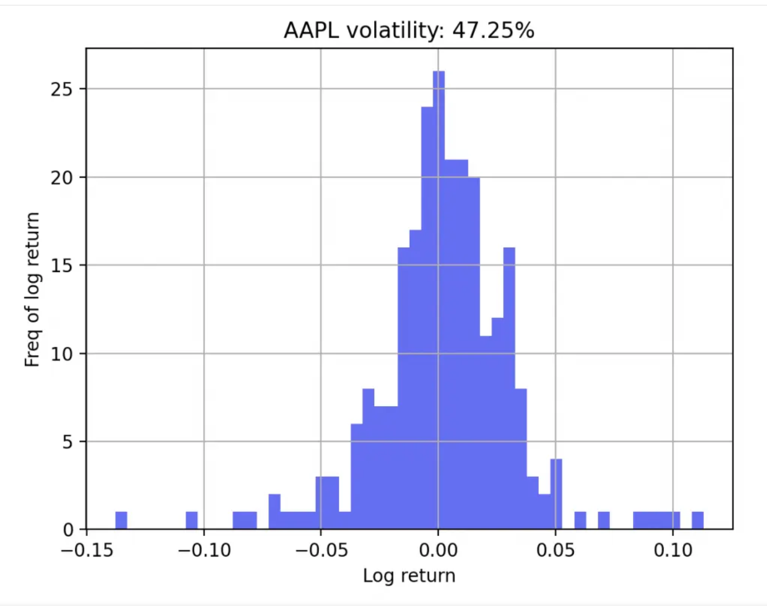

Visualizing volatility alone

Idea 7

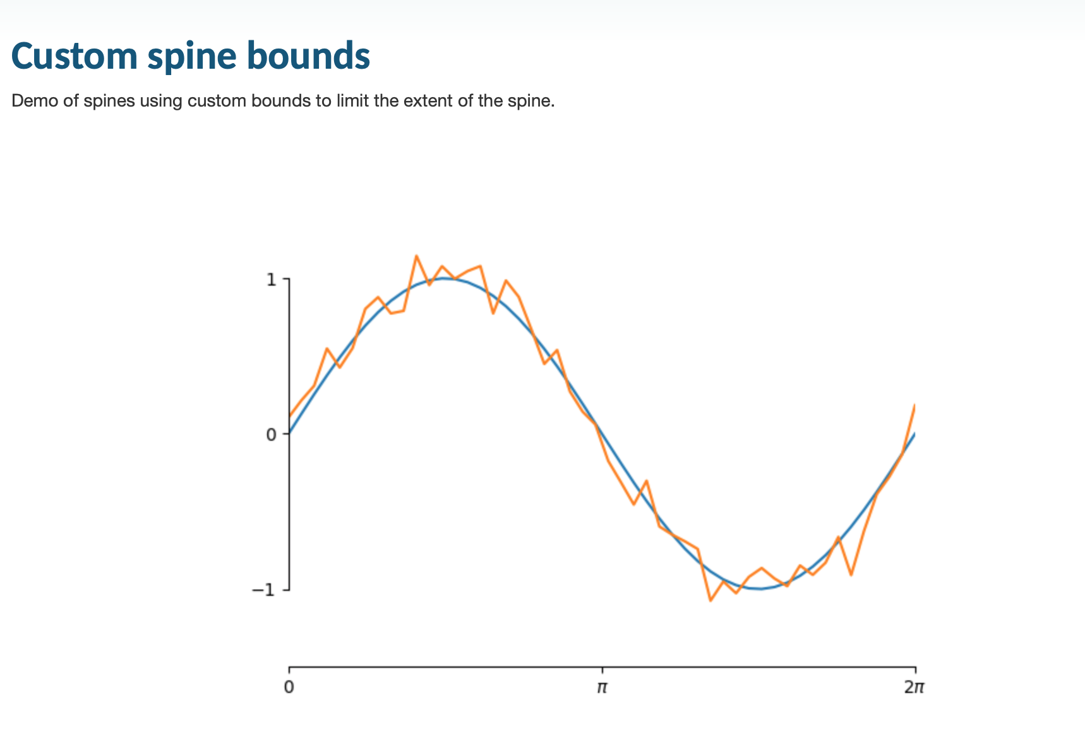

idea 8

